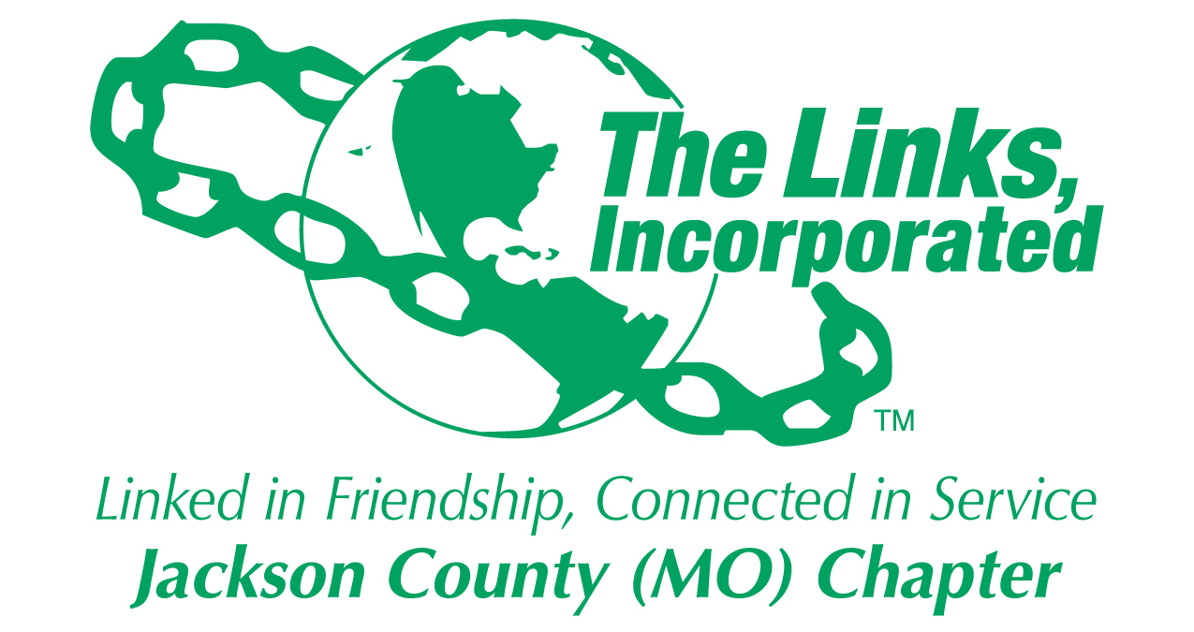

Jackson County (MO) Links
Standing Rules
2018

Section 1 – OFFICER DUTIES

President

Participate in monthly National Presidents’ Chat and other applicable National / Area webinars / chats and provide a report to the Chapter.

Vice President

Participate in monthly National Vice Presidents’ Chat and other applicable National / Area webinars / chats and provide a report to the Chapter.

Annually assist in planning of chapter workshops and retreats.

Recording Secretary

Participate in monthly National Recording Secretary Chats and other applicable National / Area webinars / chats and provide a report to the Chapter.

Receive Code of Ethics Member Acknowledgement form from Chapter Ethics and Standards Committee Chair.

(a) Make two sets of copies of all signed forms and provide a set to the Membership Chair and a set to the Ethics and Standards Committee Chair.
(b) File all signed copies alphabetically and store by program year; file original signed hard copies alphabetically, separated by program year.
(c) Transition both all data to the incoming Chapter Recording Secretary.

Financial Secretary

Participate in monthly National Financial Secretary Chat sand other applicable National / Area webinars / chats and provide a report to the Chapter.

Treasurer

Participate in National / Area Chats and other applicable National / Area webinars / chats and provide a report to the Chapter.

Section 2 - COMMITTEES

Committee Chairs

Participate in monthly Program Pearls chats and other National / Area chats and webinars.

Courtesy Committee

Courtesies shall be offered as follows:

1. Member birthday: Card
2. Member illness: Card
3. Member extended illness (more than 3 weeks): Card and plant
4. Member births: Card
5. Heir-o-Link graduation: Card and gift certificate
6. Bereavement – Member: Card, plant, or contribution to family, or contribution to organization designated by Chapter member. Contribution is to be made in consultation with family. Courtesy chair will prepare a resolution for president’s signature and presentation to family.
7. Bereavement – Connecting Link or Heir-o-Link: Letter of condolence, plant or, contribution to family or, contribution to organization designated by chapter member.
8. Bereavement – Parent, grandparent, and grandchild: Letter of condolence.

(Dollar amounts to be determined by Vice President and Treasurer and approved by Chapter)

Section 3. Fiscal Year

A. Fiscal Year

1. The fiscal year is May 1 to April 30. All dues and assessments must be submitted on-line to National no later than April 1. Failure to submit national dues and assessments by April 1 will result in a fine of $50 per member to The Links, Incorporated. Dues will not be accepted after May 1st.

2. If a member has not paid her dues by May 1st of the current fiscal year, she must apply for reinstatement. Late membership dues include the following:

- Reinstatement Fee ($500)
- The Links, Incorporated ($25.00)
- The Links Foundation, Incorporated ($25.00)
- Local Chapter dues and assessments and a ten percent (10%) fee will be imposed

B. Dues Payment Schedule

- Soft deadline: March Chapter meeting. Forms of payment accepted include cash, check, money order, cashier’s check.
- From the date of the March Chapter meeting to March 28, forms of payment accepted include cash, money order and cashier’s check (no personal or business check)
- Post April 1 payment includes all dues, assessments and $50 late fee. Forms of payment include cash, money order and cashier’s check (no personal or business checks).

Section 4 – PARLIAMENTARY AUTHORITY

The current edition of Robert’s Rules of Order Newly Revised shall apply in all matters not covered by these Standing Rues and Procedures, the Jackson County (MO) Links Bylaws, The Links, Incorporated National Constitution and Bylaws and any special rules of order adopted by the Chapter or The Links, Incorporated.

Section 5 – Amendments

Standing Rules may be amended as set forth in the Jackson County (MO) Links Bylaws, ARTICLE XI, Section 2.

Standing Rules Adopted: March 14, 2015

